Documentation Contents

Internship

Information Managers Inc.

2021

TABLE OF CONTENTS

Preliminaries #

Title page #

Table of contents #

Curriculum vitae #

Acceptance sheet #

Waiver #

Company profile #

Background history of company #

Nature of operations #

Logo #

Location #

Organizational chart #

Narrative account of activities #

Valuable knowledge of daily activities #

Pictures / proof as proof of activities #

Weekly report #

Photocopy of certificate of completion #

Company evaluation for ojt #

Other documents not specified #

***Background history of company***

**Information Managers, Inc.**

       For more than 25 years, INFOMAN has established a strong track record in serving the automation needs of more than 200 clients in the Philippines, including those in banking, insurance, retail, manufacturing, distribution, construction, education and government. INFOMAN provides software applications, database, system development and integration tools as well as project services to help clients build, customize and deploy the right IT solutions.

       The continuing goal of INFOMAN is to help clients meet changing business needs by providing innovative world-class technologies complemented with proven methodology, collaborative approaches, experienced consultants, seasoned developers, in-depth knowledge and high-quality support and services.

***Nature of operations***

**INFOMAN Services**

       INFOMAN has spent more than 10 years developing Progress based Software solutions for top companies around the Philippines.

       We help our clients implement their business critical solutions thereby increasing sales, improving loyalty, reducing costs, and enhancing profitability. We are dedicated to helping you better serve your customers, but - just as importantly - we deliver exceptional customers service to you - our customer.

       That means we're with you every step along the way, providing painless implementation, thorough training and exceptional support. We get you up and running training quickly and efficiently. We help you effectively integrate our software solutions with your other installed system. And, we make sure your users have the knowledge and day-to-day technical support they need to maximize the full value of the software solution.

**What services do we provide?**

**Consulting Services**

       We exercise quick and efficient implementation keeping you aware of the best solutions for your business.

**Training Services**

       We provide complete training solutions for every level of user you need.

**Support Services**

       We provide superior and ongoing customer support, software upgrades and fixes.

***Logo of the company***



***Location of the company***

**Information Managers, Inc.**

*Suite 704 State Condominium 1,  
186 Salcedo St. Legazpi Village,  
Makati City, Metro Manila 1229,  
Philippines*

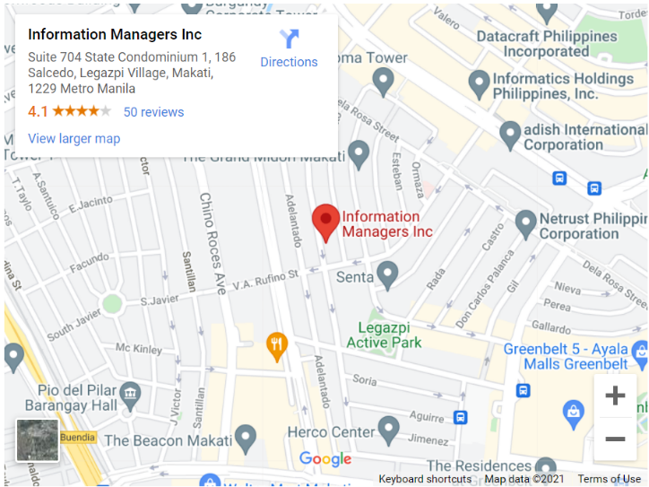

***Valuable knowledge of daily activities***

**Proof of Activities**

June 23 – 24

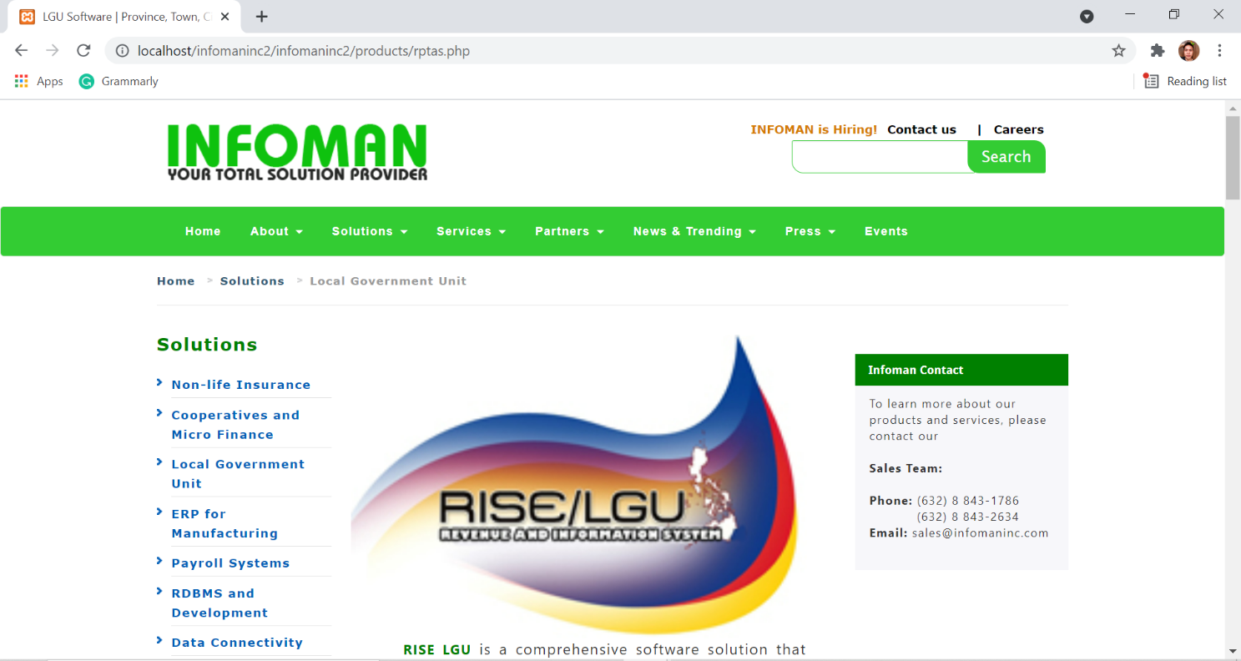Finding errors, misspelled words, dead link of Information Managers Inc’s website.

June 24 – 25

Fixing of errors, misspelled words, dead link etc.

Tools: Notepad ++, xamp and excel

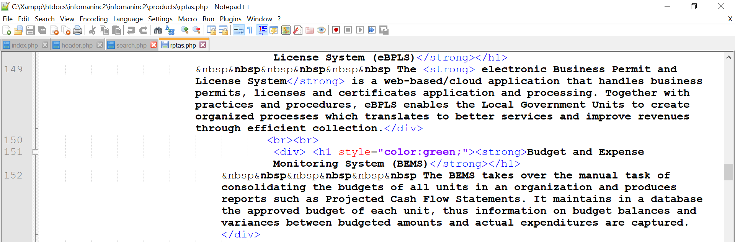

Documentation of the task

